Approval/Agreement Interjections

🔹 What Are Approval/Agreement Interjections?
# Source: AI Source: Provided by: [Data Path: Persons Table -> ID Column: 1, Name_En Column: Motasem Essam] -> From: [Chatgpt (GPT-4-turbo)] on [7/28/2025]
Approval or agreement interjections are words or expressions used to show support, agreement, or positive response to something said or done.
They express that the speaker agrees, approves, or is satisfied with something.

✅ Key Features
# Source: AI Source: Provided by: [Data Path: Persons Table -> ID Column: 1, Name_En Column: Motasem Essam] -> From: [Chatgpt (GPT-4-turbo)] on [7/28/2025]
- Show affirmation, consent, or positive feedback
- Often used in spoken language or informal writing
- Usually followed by an exclamation mark (!) or comma

🧩 Common Approval/Agreement Interjections
# Source: AI Source: Provided by: [Data Path: Persons Table -> ID Column: 1, Name_En Column: Motasem Essam] -> From: [Chatgpt (GPT-4-turbo)] on [7/28/2025]
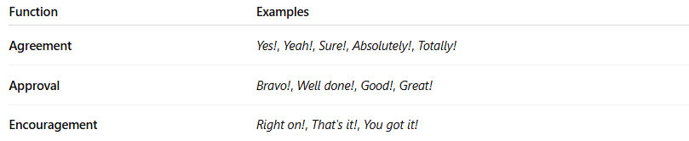
Function | Examples
Agreement | Yes!, Yeah!, Sure!, Absolutely!, Totally!
Approval | Bravo!, Well done!, Good!, Great!
Encouragement | Right on!, That's it!, You got it!

📚 Example Sentences
# Source: AI Source: Provided by: [Data Path: Persons Table -> ID Column: 1, Name_En Column: Motasem Essam] -> From: [Chatgpt (GPT-4-turbo)] on [7/28/2025]
- Yes! I completely agree with you. (agreement)
- Bravo! That was a fantastic performance. (approval)
- Sure! I’d love to help you. (agreement/consent)
- Well done! You passed with top marks. (approval)
- Absolutely! That’s the right decision. (strong agreement)

